**How to Blink an LED Using NVIDIA Jetson Nano**

**Introduction**: In this tutorial, we will blink an LED using NVIDIA Jetson Nano. I will show you how to use Python to blink an LED Here is what you will build:

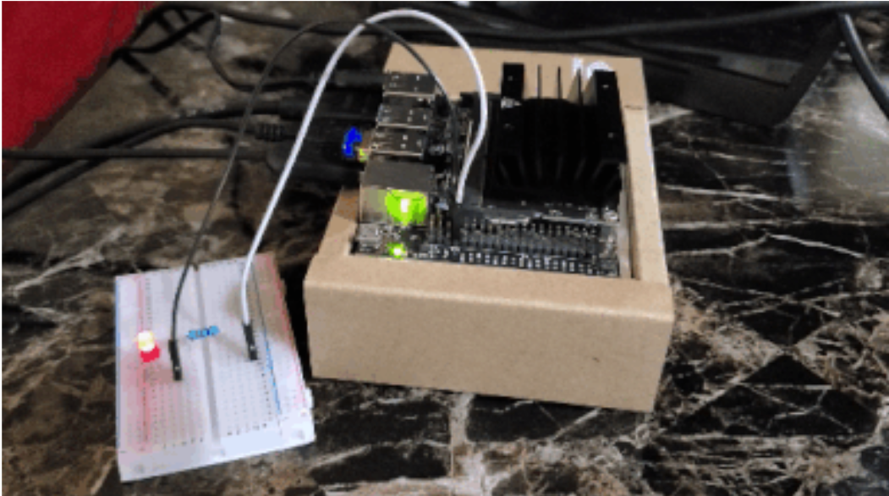

**You will need:**

This section is the complete list of components you will need for this project.

* [400 point solderless breadboard](https://amzn.to/3wrTLJY)
* [5mm LEDs](https://amzn.to/3unY6vR)
* [Assorted Breadboard Jumper Wires](https://amzn.to/3sPzNpZ)
* [220 Ohm Resistor 0.5Watt](https://amzn.to/2Pv5HK9)

**Set Up the Hardware:**

The first thing we need to do is to set up the hardware.

Gather all of the items from the “You Will Need” section and lay them out on a table.

The NVIDIA Jetson Nano board has 40 general-purpose input/output pins (GPIO). Each pin can either be an input (e.g. connecting the Jetson Nano to a sensor) or an output (e.g. an LED). GPIO pins on the Jetson Nano use 3.3V by default.



In order to get the LED to blink, we need to connect it to one of the 40 GPIO pins. Make sure you set everything up exactly like this image below:

* Connect the 220 Ohm resistor to the positive pin of the LED (i.e. the long leg).
* Connect the other end of this resistor to GPIO pin 7 on the Jetson Nano.
* Connect the negative pin of the LED (i.e. the short leg) to the GND pin on the Jetson Nano.

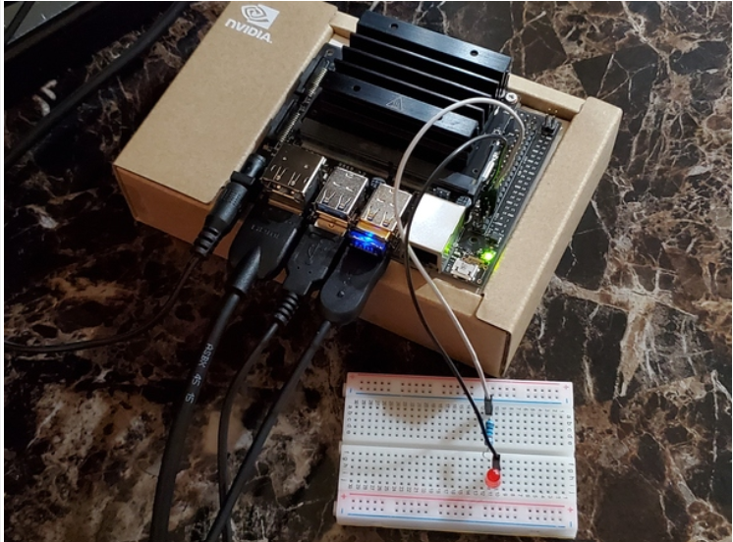 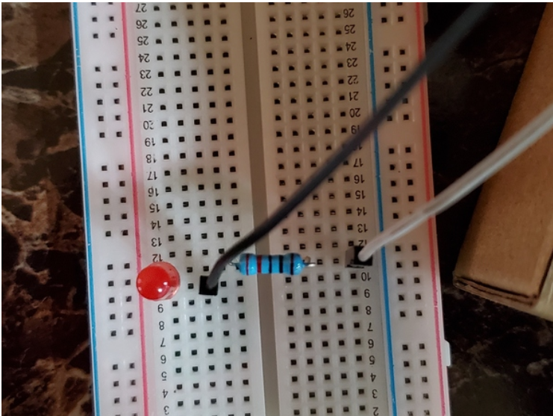 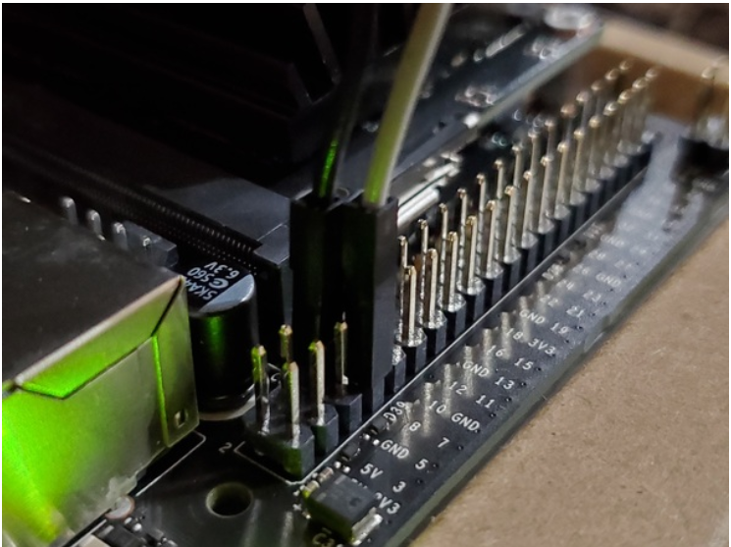

**Blink an LED Using Python**

**Set Up the NVIDIA GPIO Library for Python**

Let’s set up NVIDIA Jetson Nano GPIO.

Open a terminal, and type the following command.



If that command above doesn’t work, type the following command:



When I typed these commands, I got a message which a bunch of warning signs, but at the end of all that the following text was printed to the console:

**“Requirement already satisfied…”**

This message means that the GPIO library for Python is already installed on my Jetson Nano.

Reconfigure security permissions. Instead of your_user_name, I used automaticaddison, which is my username.

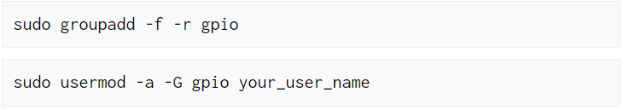

**Reboot the computer.**



**Let’s check to see if the library is fully setup.**



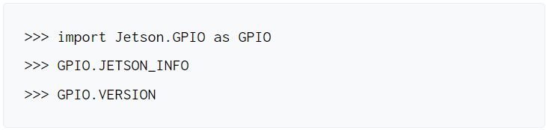

**Here is what I see:**

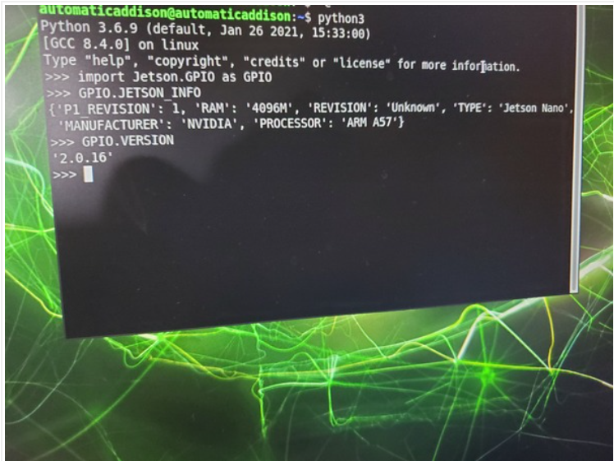

**Write the Code:**

Create a new folder. Open up a new terminal, and type:

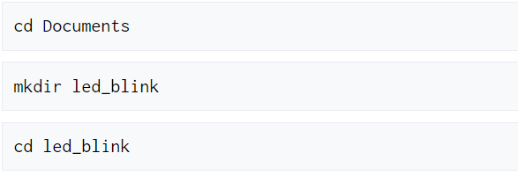

Let’s create a program to blink the LED.

Create a file named gpiodemo.py.

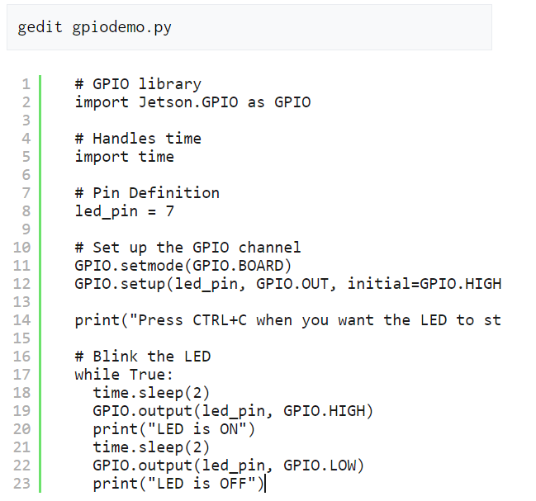

**Run the Code**

You can run your program, gpiodemo.py, in the Terminal.

Type this Command:

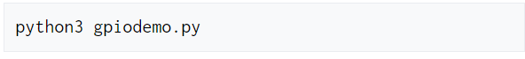

If you get any errors due to security issues, you can the gpiodemo.py file with sudo command.



You should see the LED blinking.

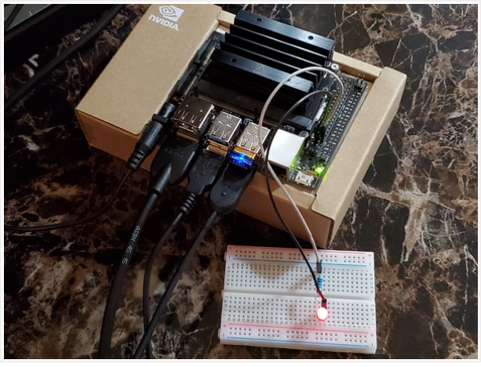

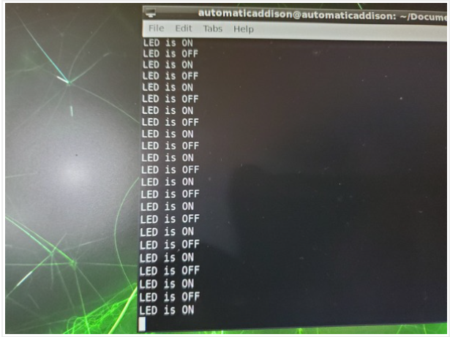

You should also see output in the terminal.

Press CTRL+ C when you’re ready to stop the program.

To shutdown your Jetson Nano, you can type:

Sudo shutdown -h now

Conclusion: In conclusion, by interfacing a single LED with the Jetson Nano using GPIO pins and Python scripting, we have successfully demonstrated basic control over the LED, turning it on and off at regular intervals. This experiment showcases the Jetson Nano's capability for hardware interfacing and provides a foundational understanding of working with GPIO pins for simple hardware projects.